IP Camera
Home/ Office CCTV Surveillance
Made Easy
DYN-750
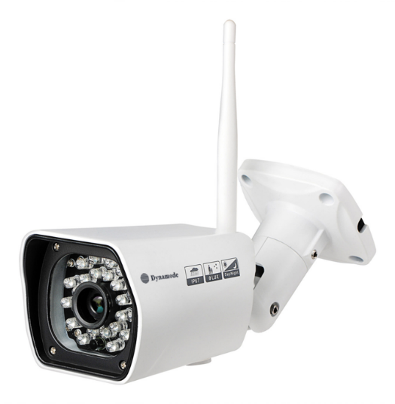

- Function and Features
The DYN-750 series is the new 2.0Mega H.264 Plug and Play outdoor IP Camera. Once you connect IP Camera to internet, no need any setting, you can see anywhere, any place, via manufacturer Mobile phone, PC and tablet software to view what you care for!

2.0 Mega IP Camera, 2.0 Mega pixels CMOS lens;
Support 64G SD card socket for recording and storage;
Have Widows PC client and Mac pc client;
Chipset Grain Media 8138S;
P2P, Plug and Play;
DYN-750 +Mobile/Tablet/PC +iSmartViewPro =3 steps Install;
Support 3 kinds of H.264 video stream and 1 way MJPEG video stream simultaneously, suitable for Local, Internet and Cross-platform view;
Support resolution for 1920*1080/1280*720;
Support 4 ways view in a video stream;
Support 802.11b/g/n protocol, build-in WiFi module to perform wireless monitoring
IR_CUT, 6mm lens;
24pcs IR LED, up to 20 meter night vision;
Support 4 times digital zoom;
Support waterproof level IP66 for outdoor use;
Built-in web server, use one port to send all the data, users can facilitates network setting;
Support ONVIF and RTSP protocol, easy to integrate it to NVR or large client software;
Support multi-languages web interface, support multi-screen to perform several view at same time;
A free DDNS have been written in device; also support several third party DDNS;
Provide free iSmartViewPro client software, support Multi-view, Long time recording, video replay etc;
Support motion detection.

SPECIFICATIONS
Hardware performance | Product type | IP camera
 | Operation system | Embedded operating system
 | Special function | Support 64G SD/TF card; have Mac PC client.
Web environment | Web protocol | TCP/IP、UDP/IP、HTTP、SMTP、FTP、DHCP、DDNS、UPNP、NTP、RTSP、ONVIF
 | LAN port | 10Base-T/100Base-TX
 | Wifi | WIFI，802.11 b/g/n
Image performance | Resolution | 1080P, 720P, 640*360, 320*180
 | Compression mode | H.264/M-JPEG
 | Max frame rate | 30fps
Other parameters | Lens | f=6mm, F=1.2
 | Min. illumination | 0 lux
 | Electronic shutter | 1/50s(1/60s)-1/100,000 s
 | SNR | 48db
 | Safety performance | Three levels of user rights
 | Install mode | Wall-mounted
 | Other performance | PC software,support for Microsoft Windows 98/2000/XP/Vista/Windows 7/Mac OS,And the Internet Explorer6.0 and above ,Firefox,Chrome,Safari etc.,  provide iSmartViewPro client software
 | Power supply | DC 12V
 | Sensor | 1/2.7’’ CMOS Sensor
 | IP camera performance | Support motion detection, external alarm(sends information to alarm the server by Email, FTP);Manufacturers provide free DDNS, and has been written into equipment;  24pcs IR LED, up to 20 meter night vision;  automatically control through the photoresistor;
 | Audio input | None
 | Audio output | None
 | Alarm in | None
 | Alarm out | None
 | Power consumption | Power<8W
Appearance parameters | Body size | 200*70*65mm
 | Product weight | 0.89kg
Environment parameters | Environment temperature | -10℃~50℃
 | Environment humidity | below 85% RH

Packing List
1, IP Camera* 1
2, Driver and tool CD *1
3, Quick installation guide
4, Network Cable*1
5, Power Adapter *1
6, Wi-Fi Antenna*1
7, Screw*1kit

